Lab 7 Report
Andrew Kong, Aren Muniz, Kai Ong, Daniel Lopez, Kaushik Vada
May 29, 2026

Abstract:
This lab focuses on using a proportional-velocity (PV) controller for QUBE-Servo position control. A Simulink model was developed and tested to evaluate the effects of proportional and derivative gains on system performance. Controller gains were designed using second-order system specifications and implemented on the servo. The resulting position response was analyzed to verify that the desired peak time, overshoot, and overall stability were achieved.
1 System built
The system built in this lab was a proportional-velocity (PV) position control system for the Quanser QUBE-Servo. The system was implemented in Simulink and consisted of a reference signal generator, a proportional controller, a velocity feedback path with a high-pass filter, and the QUBE-Servo plant. A square-wave position command was used as the reference input, while the measured servo position was fed back to the controller. The proportional gain was used to improve tracking performance, while the derivative gain provided damping and reduced overshoot. The completed system was tested to evaluate position-control performance and to verify the controller gains designed from second-order system specifications.
2 In-Lab Exercises and Results
- 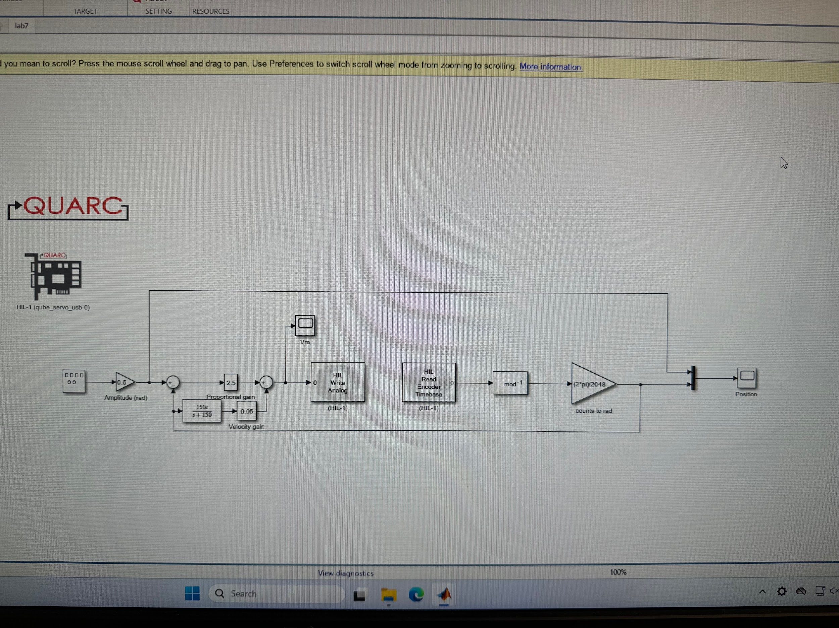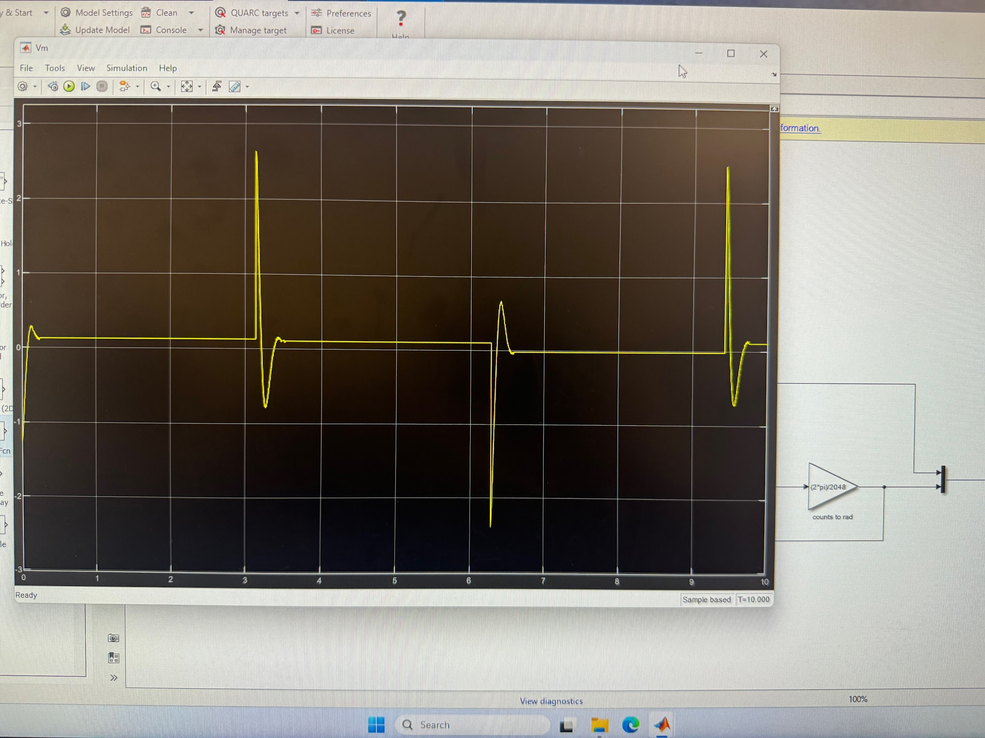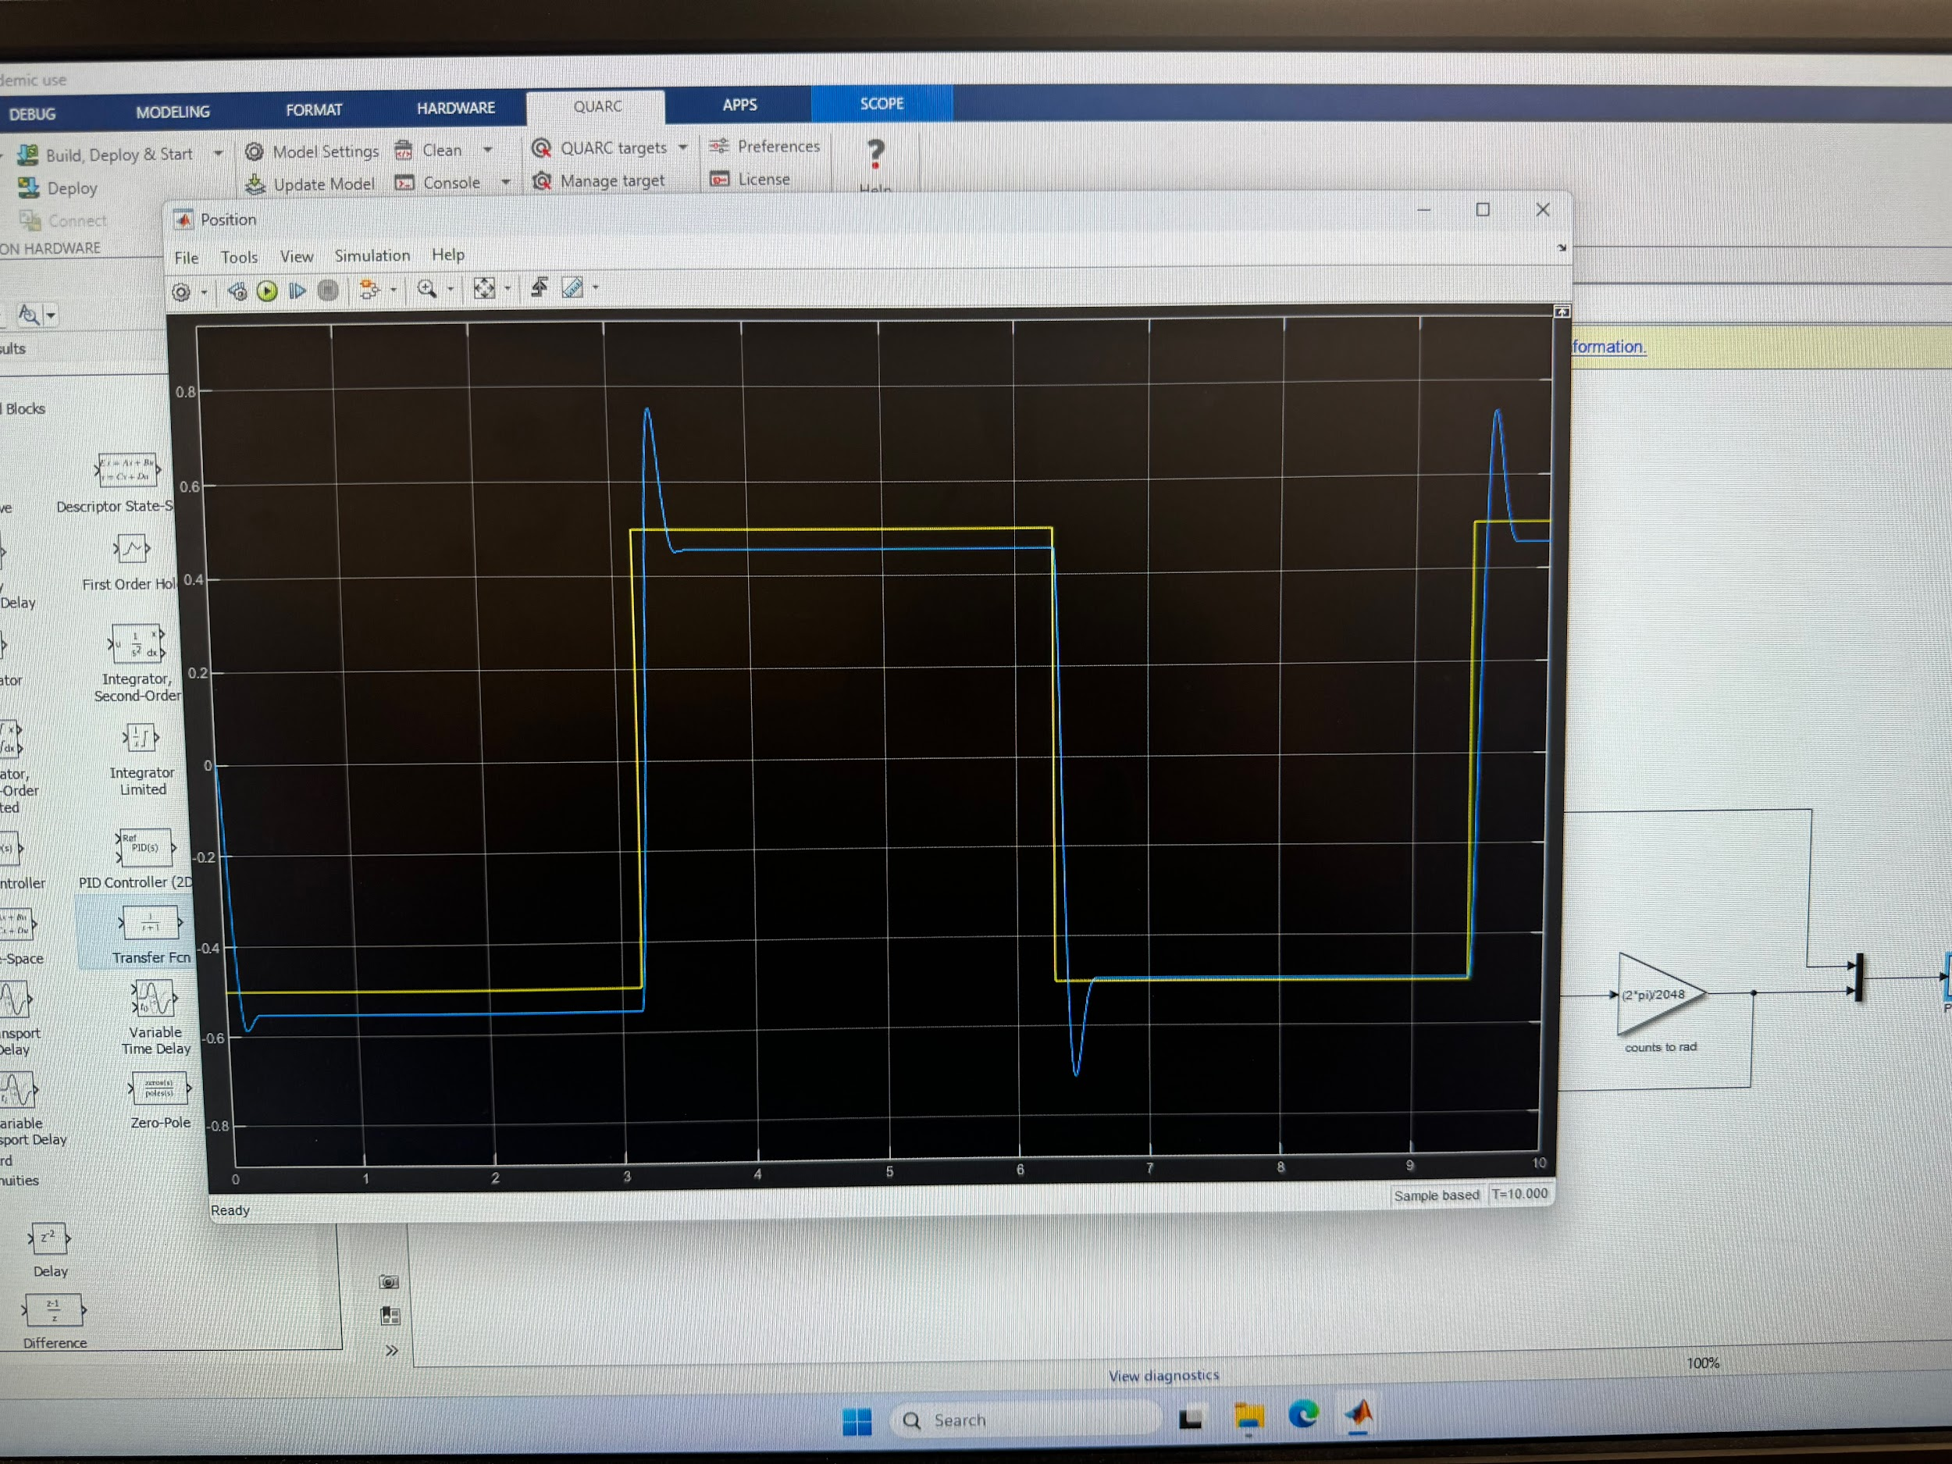
- Kp = 1, amplitude is not as high, previous was around 2.5, this is around 1.
Kp = 2, the output has more oscillations, or at least the smaller oscillations are now larger
Kp = 3, even more oscillations than when Kp = 2
Kp = 4, even more oscillations than when Kp = 3.
We can see as we increase the value of Kp that there are more oscillations. This shows that the servo is moving more frequently the higher the value of Kp.
- As Kd increases, the output result becomes similar to the reference.
- X
- Matching the QUBE-Servo closed-loop transfer function to the standard second-order form, we get $k_{p}=\frac{τ{ω_{n}}^{2}}{K}$ → $k_{d}=\frac{2ζω_{n}τ-1}{K}$
- Using $w_{n}=32.3 ζ =0.76 K = 23.2 τ=0.13$ → $k_{p}= \frac{(0.13)(32.3)^{2}}{(23.2)}=5.85$ $k_{d}=\frac{2(0.76)(0.13) - 1}{23.2}=0.232$ therefore we get $k_{p}=5.85 V/rad$ and $k_{d}=0.232 V/(rad/s)$
3 Analysis
Results analysis: The PV controller successfully controlled the position of the QUBE-Servo and demonstrated the effects of proportional and derivative feedback on system performance. Increasing the proportional gain improved the speed of the response and reduced tracking error, but excessive proportional gain increased overshoot and oscillatory behavior. Increasing the derivative gain added damping to the system, reducing overshoot and improving stability. Using the calculated gains, the servo response closely followed the reference position with a fast rise time and minimal overshoot. Overall, the experimental results were consistent with the theoretical second-order system model and demonstrated that PV control can effectively improve transient response while maintaining stable operation.
Issues encountered:
4 Conclusion
In this lab, a proportional-velocity (PV) controller was designed and implemented to control the position of the QUBE-Servo system. The effects of proportional and derivative gains on the transient response were investigated, and controller gains were calculated using second-order system design specifications. Experimental testing showed that proportional gain increased response speed while derivative gain improved damping and reduced overshoot. The final controller achieved stable position tracking and demonstrated the effectiveness of PV control for servo position regulation. Overall, the lab provided practical experience in control system design, tuning, and performance analysis using a real electromechanical system.

